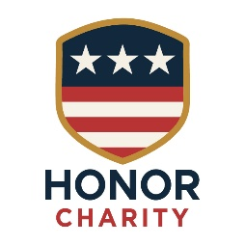

Ethnicity & Demographic

Self-Identification Form
Purpose:
Honor Charity is committed to serving veterans and their families across Southern Arizona with fairness, transparency, and inclusivity. This optional form helps us understand the communities we serve and improve our programs, outreach, and grant reporting.
Providing this information is completely voluntary and will NOT impact your eligibility for assistance.

Applicant Information
Full Name: Date: ____ / ____ / ______

1. Ethnicity (Select all that apply)
☐ Hispanic or Latino
☐ Not Hispanic or Latino
☐ Prefer to self-describe: __________________________
☐ Prefer not to answer

2. Race (Select all that apply)
☐ American Indian or Alaska Native
☐ Asian
☐ Black or African American
☐ Native Hawaiian or Other Pacific Islander
☐ White
☐ Middle Eastern or North African
☐ Other: ____________________________________
☐ Prefer not to answer

3. Cultural or Community Identity (Optional)
This question helps Honor Charity better understand the diverse veteran community in Tucson and Southern Arizona.
☐ Veteran Community of Color
☐ Indigenous / Tribal Affiliation: __________________
☐ Immigrant or First-Generation American
☐ Military Family / Veteran Household
☐ Other Identity (optional): _______________________
☐ Prefer not to answer

4. Language Preference (Optional)
Primary Language Spoken at Home:
☐ English
☐ Spanish
☐ Other: __________________________
Would you prefer program communications in another language?
☐ Yes: __________________
☐ No

5. Confidentiality Statement
The information provided in this form is confidential and used solely for:
- Program impact reporting
- Grant and donor reporting
- Community needs assessment
- Improving equitable service delivery
This data is never used to determine funding decisions or eligibility for assistance.

Signature
I understand this form is will be used for demographic reporting purposes only.

Applicant Signature: Date: ____ / ____ / ______

